CREATING, COMPILING AND RUNNING AN RMI APPLICATION

Step 1:

Develop Remote Interface

Example: date.DateServer.java

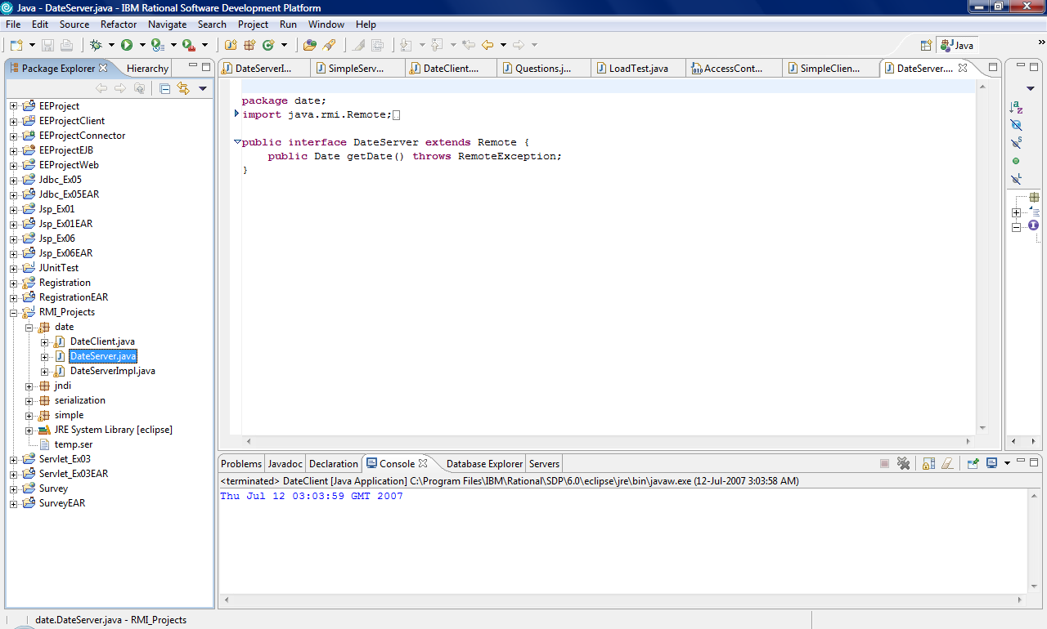

Step 2:

Implement Remote Interface

Example: date.DateServerImpl.java

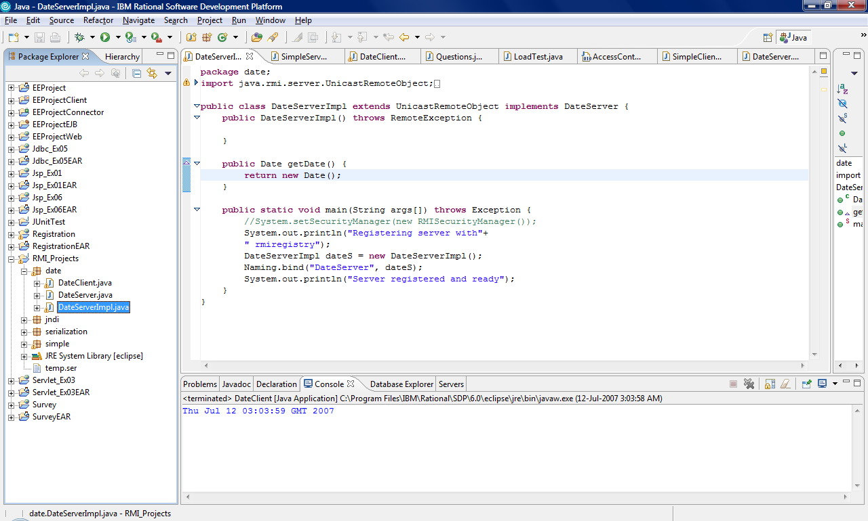

Step 3:

Create Client Application that connects to the server object using Naming.lookup()

Example: date.DateClient.java

Step 4:

Compile these classes.

To do this, you can either use RAD6/Eclipse or Command Prompt. If you use command prompt, use javac date\*,java

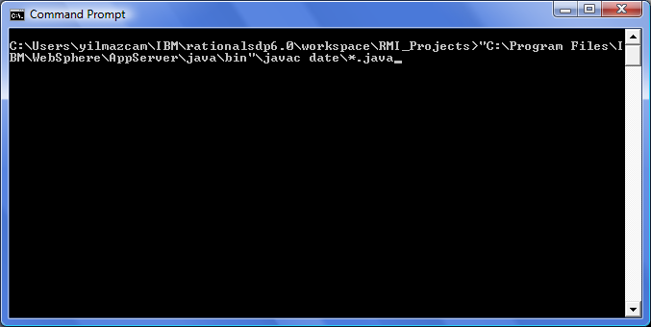

Step 5:

Run the RMI interface compiler on the .class file of the implementation
class (in this case, you'd say "rmic date.DateServerImpl").

You need to switch to directory where date package is located. In my example, it is C:\Users\yilmazcam\IBM\rationalsdp6.0\workspace\RMI_Projects\

If rmic is not in PATH, you either need to add it to PATH or run it from its location.

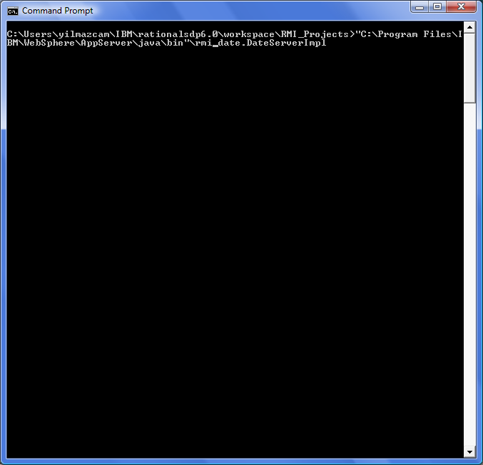

At the end, you should see DateServerImpl_Stub.class file under date directory.

Step 6:

Create a jar file that includes server side classes.

Jar cvf c:\temp\date.jar date\*.class
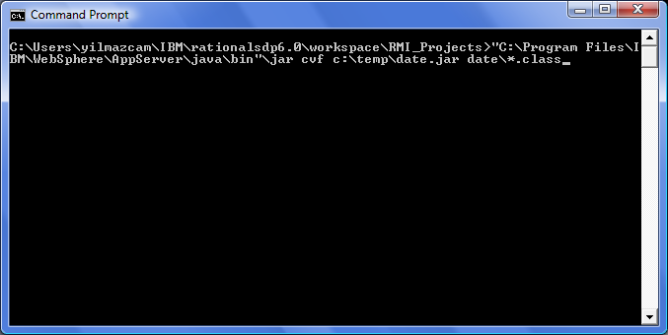

Step 7:

Add the jar file into CLASSPATH. You can do that by adding system’s environment variables.

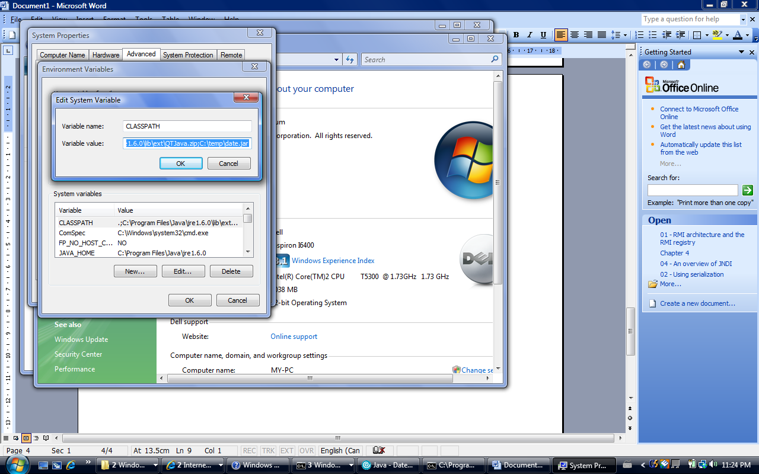

Step 8:

Start the RMI registry (on Windows, say "start rmiregistry" from command prompt). If it is not in PATH, you need to switch the directory where it is located.

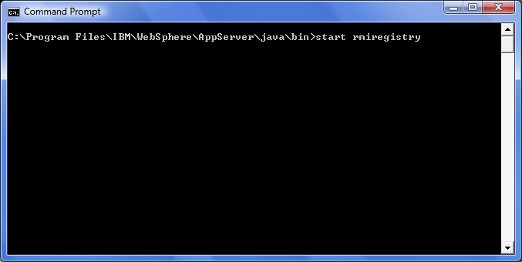

It is going to open a new window.

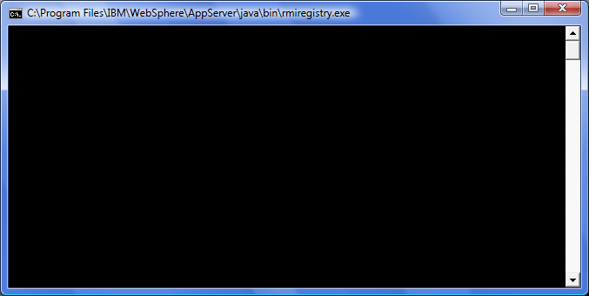

Step 9:

Start the server class ("java date.DateServerImpl").

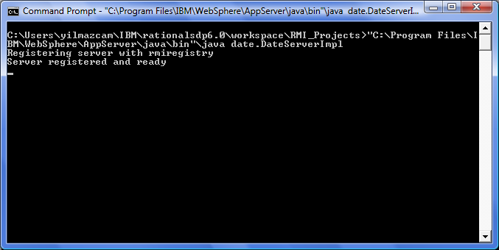

Not: If you are getting

Exception occured: java.rmi.UnmarshalException: Return value class not found; nested exception is: java.lang.ClassNotFoundException: date.DateServerImpl_Stub

exception, that means there is a problem with your CLASSPATH settings. Double check with your classpath. After fixing the problem, you should stop and restart rmiregistry.

Step 10:

Run the client program by passing localhost parameter ("java date.DateClient localhost"). You should see server’s time, in this case localhost which is same as client.

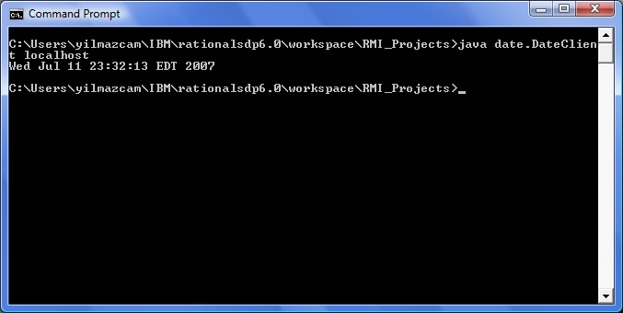

Or you can run it from RAD6/Eclipse

